Project Design Phase-I Solution Architecture

|  |  |
| --- | --- |
| Date | 24 September 2022 |
| Team ID | PNT2022TMID43251 |
| Project Name | Smart Waste Management System For Metropolitan Cities |
| Maximum Marks | 4 Marks |

Solution Architecture Diagram:

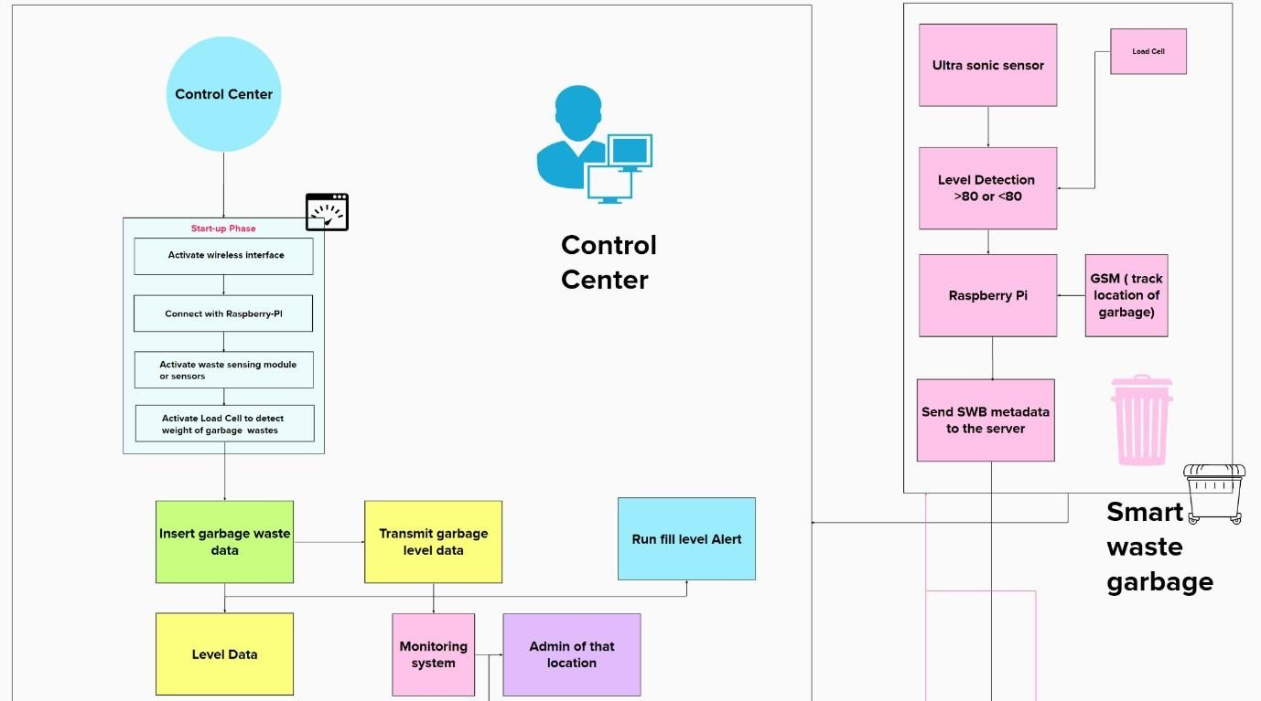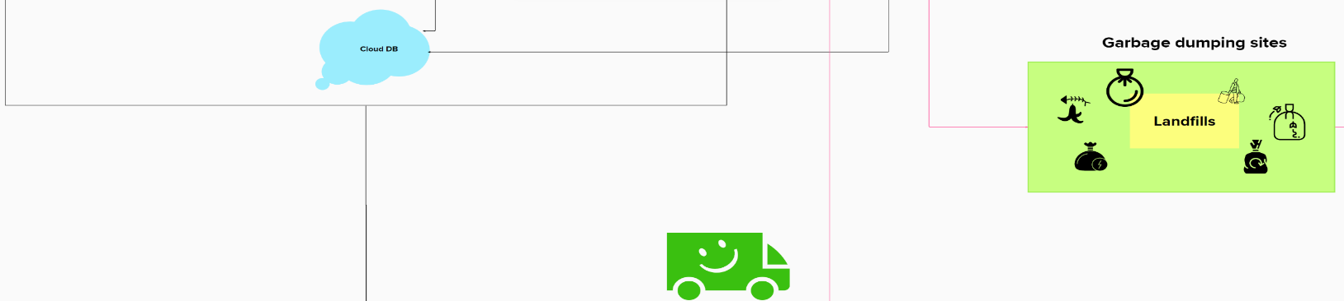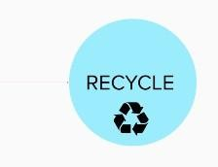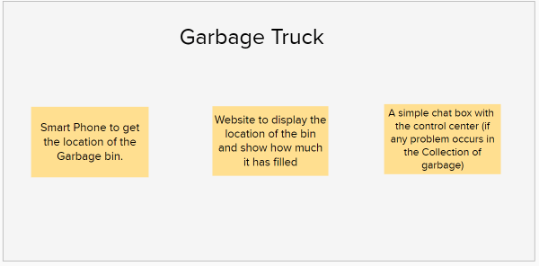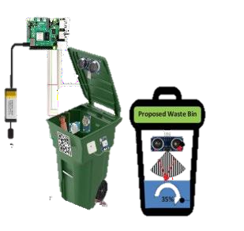

**Raspberry pi**

(send garbage level and the location to the sever)

**Ultrasonic Sensor** (measure the distance of the waste in the Bin)